
Loyalty Tri-V Umph
Cooperation January 2010
Friendship

President-M.Trachsel-586-484-0836 Sec.-D. Angelosanto-734-422-3501
V. President-M. Van Hollenbeke-734-765-2555 Treas.-J. Mackson-734-525-0537

President’s Message

The holidays have come and gone. I hope you all had as nice of a holiday season as I did, spent with family and good friends. I really enjoyed having some time off work. Although, I was somewhat glad to go back just to get back to a normal daily schedule. I had so many plans to be productive over the holiday break, but the time went by so quickly that none of them seemed to get finished.
I hope to see you all at the council party. The bowling should be fun, I know everyone had a great time the last time we did this a couple years ago. I hope everyone has a wonderful 2010!
Mike

Memories of Bob Wendt

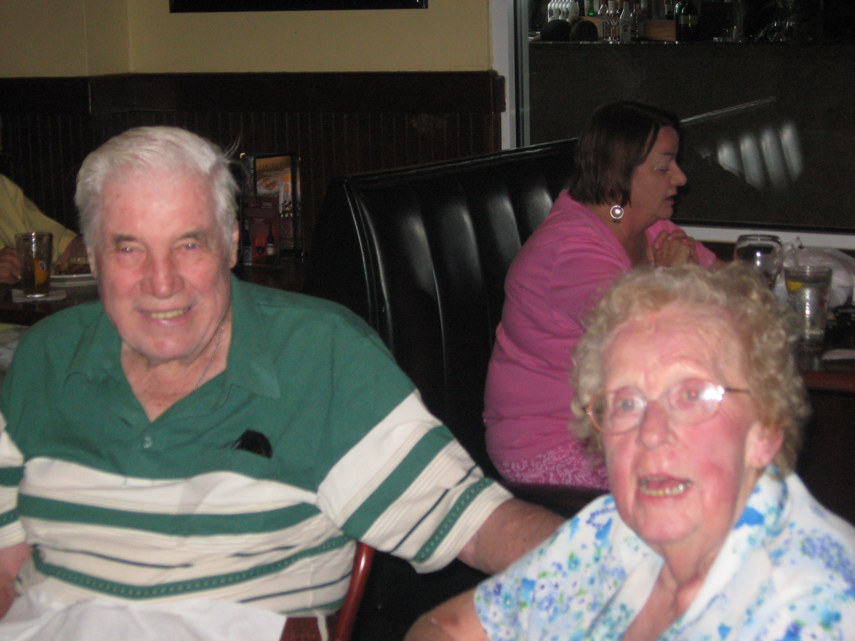
Bob and I go back as far as 1939 when he lived two doors from me in N.W. Detroit. He was my first employee to help me deliver the Detroit News. His pay was to ride in my 1936 Plymouth while we delivered the papers. Bob was going to a Catholic grade school and later to Redford High, while I went to Cooley. He joined the Navy in WW11 and was stationed aboard Merchant Ships as an Armed Guard. After the war his Mother introduced him to a cute red head from her work (Peggy Shay) who he couldn't resist and later married. In 1947, (?)I sponsored Bob in the Tri-V Club where he was an active member for many years. We enjoyed many Motor home trips and cruises with the Wendts and will really miss them. We said "Goodbye" to him on December 17th at the Florida National Cemetery, Bushnell, Fl. They played taps and gave him a gun salute -Tri-V was represented by Onallee, and Bill Trachsel, Geri Ruetenik, Shirley and I and of course Kathy & Art. Bob will be missed, but not forgotten. Bill Suchner

Girl’s Club

The next Girl’s Club Mtg. will be held on January 20, 2010 at the home of Delores McMillan.
ALL ladies associated with Tri-V are welcome

TRI-V WIVES Christmas Dinner

On Wednesday, December 16, Tri-V Wives celebrated Christmas at Plymouth Crossing in Plymouth. There were many menu choices including soup, salad, entrees, and dessert. The choices included Ribeye Steak Sandwich, Chicken Tuscany (chicken with artichokes), Fish & Chips, etc. After dinner each person was asked to tell of a special Christmas they remembered and why it was special.. A gift exchange was held after we finished telling our stories. During the opening of gifts,Santa (Terry Connolly) stopped in and provided each of us with a candy cane and "ho, ho, ho". Those in attendance were Sherry Kuhr, Karlyn Gies, Victoria Angelosanto, Sherry Steinhauer, Bev Lardin, Jan Cashman, Jacqui Schaefer, Dolores McMillan, Babs Wagner, Peg Hoffman, Blondie Forsyth, Barb Gies, Marian Anderson, Ellie Connolly and Judy Lardin. Unfortunately Marlene Wutka became ill and could not join us. A big Thank You to Ellie Connolly for choosing Plymouth Crossing for the celebration.

Tri V Children’s Christmas

The Tri V children’s Christmas party was held on 1:30pm Sunday December 6th at the Maple Lanes golf Club in Sterling Heights. We had snacks, cookies and drinks. The kids spent time decorating Christmas cards and envelopes and running around. The Maples worked out well for this type of function because the kids had ample room to play. The turn out was somewhat disappointing with only 10 children and 25 adults. We did have 2 families that could not come due to sick children. The main event for this party as always is Santa who arrived around 2:30. He was a hit as usual and only 1 child cried this year. Santa handed out the gifts brought by the parents along with candy canes, crayons and a coloring book generously donated by Norma Battel.

The committee would like to thank Norma Battel for the coloring books as well as Jason and April Osborne who brought Christmas stamps with stamp pads that they donated for use at the next children’s party if needed. As with all Tri V events many people pitched in to help set up and clean up when it was done. We certainly appreciated the help. I would like to thank my committee Bob Kuhr and Dave Burke with a big assist from Sherry and Liz. Dave also semi volunteered to do his 1st tour of duty as Santa. Good work Dave I hope you make this a yearly side job.
Your committee Jay Trachsel, Bob Kuhr, Dave Burke

Book Club

The book club discussion was held on Tuesday, Jan. 5, 2010 at Sherry Kuhr's. The date was made early so that Judy could attend prior to leaving for FL. Book we are discussing is "The Help" by Kathryn Stockett. The next book club discussion is scheduled for Monday, April 19 at Jacqui Schaefer's. Book to be discussed is "The Help" by Karen Stockett.

No book club discussions will be held the month of February or March due to absences of members. Members--keep reading and let's each find a book to recommend at the April meeting.

Council Party
January 23, 2010
Novi Lanes
21700 Novi Road
Novi, MI 48375

Please arrive at 5:30. Bowling begins at 6:00 sharp and we need a few minutes to get shoes and assign people to lanes. After bowling there will be pizza, salad, and subs.

No bowling skill is required. ( It may be a disadvantage). If you haven’t already let the council know if you are attending, please do so quickly. We must give a final count by Monday, January 18. If you would like to come to watch and eat but not bowl, please let us know.

Matt V., Bill T, Steve T, Jeff T, Brian T, Jack S and Nick A

Fall Social Event
Fall social event was held December 13, 2009 at 2:00 pm. There was a total of 13 people that attended 5 members and 8 guests. The group attended a play, Miracle on 34th street, put on by the Farmington Players located on 12 Mile Road in Farmington Hills. The play was enjoyed by all that went, the actors were not professionals but they did a darn good job. The cost of the event was $13/for the guests and the members were free since the club allocated $100 for this event. Thecost to the club was $65 and $35 was returned to the club. After the play those who attended went to Ruby Tuesday's for dinner. This was a cold dreary Sunday, so the play and being with friends turned it into a bright cheery day. Your committee, Matt Hoffman, Tim Gies & Tom Untener

February Social Open Event
Friday, February 12, 2010, club members and guests will be going to Mallie’s Sports Grill and Bar at 5:30 pm for a very reasonably priced dinner (order off the menu). Mallie’s is located 2 miles east of Telegraph Rd at 19400 Northline Rd., Southgate (734) 287-0800. Check out the menu at www.malliesbar.com .
Dinner will be followed by a varsity basketball game coached by John Mackson and played at Taylor Kennedy High School at 7:00 pm. The school is located .3 miles east of Telegraph on the south side of Northline Rd. Admission $4.00 per person.
Everyone (children also) is invited to both or either event. Please RSVP for dinner to Jack Schaeffer 248-349-7359 or Nick Angelosanto 734-522-5366

Tri-V Pinochle schedule 2009/2010

Feb. 6

Cashman D. Angelosanto
Barnes Kuhr
Stress T. Gies
Connolly Hollenbeke/M. Hoffman
Clingerman J. Trachsel
Schaefer B. Trachsel
N. Angelosanto M. Trachsel/Bliudzius
M. Lardin

March 6

N. Angelosanto J. Trachsel
Barnes Stress
Schaefer Clingerman
D. Angelosanto B. Trachsel
M. Vanhollenbeke/M. Hoffman M. Trachsel/Bliudzius
M. Lardin Cashman

NOTE:

If you need to cancel call Cal Cashman at 248.669.9209. It is not the Hosts responsibility to find a sub. PLEASE BE SURE TO WRITE AN ARTICLE FOR THE PAPER AFTER HOSTING.

January Pinochle at the Schaefers
Cards at the Schaefers was lots of fun even tho Terry Connolly would not take his pants off. The Cashmans, Mike & Romas, B. Trachsels, Jeff & Karen, and the Connollys brought a variety of food. We even had yummy Christmas cookies for dessert. Jack Schaefer came in first, Jeff Trachsel 2nd, Terry Connolly 3rd and Jane Trachsel and Jacqui Schaefer tied for fourth. It was a great way to start the New Year.

Note: No Scoresheet was received

Trifles

From the Clingermans
Our Christmas involved going to Wickenburg, AZ for a family reunion of Donna's side of the family. There are only 12 of us but it's still hard to gather people from Michigan, Colorado, California, and Arizona. We rented two condos near Donna's mother's place which is 90 minutes from Phoenix. Her mother got to meet her great granddaughter! Unfortunately, Isabel was not too enthralled with any of us until toward the end. We did some work - would you believe 5 truck loads of "stuff" from their sheds to the dump and we barely got started, and toured a safer place for her Mom and husband to live. We may even get them to move! Lots of visiting, lots of eating. Our flight home to Detroit was cancelled so we ended up with an extra warm sunny day in Phoenix. As an added note, you Detroit area homeowners will not be pleased to hear that our 2800 sf condo which backs to the woods is worth LESS than Mom's double wide in the middle of nowhere. Sigh.

From the Rueteniks
Geri Ruetenik had surgery the Monday before Christmas to remove a spot on her lung. She spent the Holiday in the hospital returning to her home in Florida on December 27th. Dave's daughter and son-in-law were down there to take care of Dave. She was in a lot of pain when Onallee Trachsel went to visit with her. We do not know what they found but chemo was mentioned. As always please keep her in your prayers and cards seem to be preferred rather than calls.

I received this letter from Geri today:

Hi Everyone
Now that I know a little more I can share it with you. The biopsy on my lung was cancer so they went ahead with the surgery and removed all of it, they think. This was on Dec. 21st. I was released from the hospital on the 27th and am in the process of coordinating home health care, chemo and radiation. I don’t know yet how long this will take or the prognosis. I appreciate any prayer or concerns you have had for me. Please keep me in your thoughts. Your cards and support have been wonderful.

Love, Geri

From the Cashmans
Jan & Cal flew to Plano, Texas over Thanksgiving to visit with their daughter Julie, son-in-law Larry granddaughter Ashley and their monster dog (English Mastif/220 lbs/3 1/2 ft tall, gentle as a giant) Boozer. We were picked up at the airport by Julie & Larry the Thursday before Thanksgiving and went to see their new home. It is a very nice five bedroom home with a swimming pool and hot tub in the back yard. It was too chilly to swim in the pool but we did enjoy the hot tub. We spent the weekend shopping for their Christmas presents so that would be one less box to send out when we got home. Julie & Larry had to work and Ashley was still in school the three days prior to Thanksgiving so we used one of their extra cars and took off for Austin and San Antonio. The weather was in the low 70's while in Austin so we got to do a lot of sightseeing. We visited the State Capitol Building, the LBJ Library and walked around the city for a few hours and then went to a restaurant overlooking beautiful Travis Lake for lunch. Julie's girlfriend told us about Travis Lake. The next day we went to San Antonio and visited the Alamo and the Riverwalk area. What a beautiful place to visit. We headed back to Julie's home Wednesday evening and encountered Thanksgiving Eve traffic. What a mess! A trip that would take about 3 1/2 hours took 6 1/2 hours! We enjoyed Thanksgiving Day with some of their friends and enjoyed so much good food we couldn't even try the dessert. The guys watched football and the girls talked and cleaned up the kitchen. No surprise there, right? We enjoyed our kids and granddaughter so much, we watched movies, played cards, went to church, went out for lunch and sometimes dinner, Julie cooked a delicious meatloaf dinner one evening, enjoyed the hotub and the day we were leaving it was snowing. We had a wonderful trip and hope it won't be long before we can get together again hopefully at our house this time. We spent Christmas in Ohio with my Mother and brothers and their families and had a very fun time. Mom is fading slowly but was able to go to my brother's home for Christmas. Please keep her in your prayers. We hope everyone had a wonderful Christmas and want to wish everyone a very Happy New Year.

From the W. Trachsels
We (Bill and Onallee) received a Christmas card from Marge Stock’s daughter, Kathy. Marge is still in the same nursing home in Franklin, Tenn. She is still doing about the same health wise. She talks very little. Her memory is not sharp like we remember Marge and does not always remember people. Kathy says that she recognizes her sister Patty,
Kathys address is : Kathy Keith
122 Gallagher Dr,
Franklin, Tenn.37064

From the Schaefers
Schaefers traveled to Bloomington Indiana to help out our son for a week. We expected to see brown grass and mild temperatures. Not the case, we are in sub-zero temps and have about 6 inches of snow. Jack has shoveled 6 times. So while our son is in Mexico we are freezing in Bloomington. I think your temperatures are warmer in Detroit. Count your blessings.

From the J. Lardins
Here it is the first month of a new year and once again the good Lord must be looking after John Lardin. On the Mon. after Christmas Judy and John got their SWINE Flu shot. At the time john was feeling a little blah but not enough to prevent him from getting the shot. By Wed. evening John was feeling like crap and being the New Years Day weekend all the Doctors were closed. He felt he could hold off until after the weekend and finally got to the Doctor on Mon. the 4th of Jan. The diagnosis was a viral infection that had turned into an upper respirator infection and fortunately had caught it before it turned into pneumonia. Happy to say that after a few meds for five days John is feeling well enough to start packing to leave for Ft. Myers on Mon., Jan. 11th. Judy and John Lardin will be staying in the same condo they had last year in Ft. Myers. Last year they were there from Jan. 15th thru Feb. 28th. John wanted longer and Judy agreed as long as she could come home for granddaughter Bella’s birthday the first part of March. The condo agreed to allow them to lease this year from Jan. 15th thru April 14th. Once again Judy’s Mom is going but has not said how long she will stay, possibly returning when they come back for Bella’s birthday. John had one of his epiphanies and decided to bring Gina, Bella and Dante to Ft. Myers for their spring break from Thur. Feb. 11th, thru Tue., Feb. 16th. So only time will have the answer to their returning for Bella’s birthday and how long Grandma will stay. Judy thinks if the weather in Illinois is bad enough she will stay the full three months.

From the Macksons
Dominic and Madison Mackson (son and daughter of John and Robyn) are happy to announce that they will be getting a little brother or sister sometime in June. Mom is doing well.

Belated Xmas Greetings from the Stresses
Happy Holidays to one and all. This has been a very good year for Kate and myself. We both are retired, we're enjoying our new freedom and relaxation away from the demands of the daily "eight to five". Our son and daughter and their families are doing well. Our grandson, Julian is growing like a preverbial weed. We are grateful every day for our many blessings. We wish all of you Health and Happiness, and a most Joyous Christmas and New Year.

Calendar of Events

January February
2nd Pinochle 6th Pinochle
13th Men’s Mtg 10th Men’s Mtg
(Walker’s Speakeasy 6:30 pm) (Walker’s Speakeasy 6:30 pm)
20th Wives Mtg 12th Feb. Social
(McMillan 7 pm) (Mallie’s 5:30 pm) Game (7 pm)
23rd Council Party
(Novi Bowl 5:30 pm)

January Birthdays February Birthdays
2nd Geo. Hoffman 1st Eric Hoffman
17th Diane Plocharczyk 2nd Ken Stress
19th Marge Stock 7th Romas Bliudzius
23rd Geoff Steinhauer 9th Tim Gies
27th Bob Kuhr 11th Babs Wagner
30th Jack Schaefer 13th Lynne Barnes
18th Debbie Lockhart
22nd Tom Untener
23rd Bonnie Untener
24th Sherry Kuhr
26th Esther Chamberlain
28th Helene Ryan

January Anniversaries February Anniversaries 1-3-75 Tim & Karlyn Gies None

MEMORIES FROM THE JANUARY 2000 ISSUE OF TRI-V UMPH

The New Year started out with two of our original members battling health problems. First was Brady Brenton who had been battling pneumonia for over three weeks and was still in a much weakened condition and secondly was Jack Henry who attempted to get up by him and fell and gashed his head. After a trip to the emergency room he is back in the nursing home and now needs help to get up and can no longer feed himself and is in very poor condition. Pat Foley has been bothered with a pinched nerve that has restricted the use of his right hand. We were asked to remember these members in our prayers. Diane Plocharczyk had accepted a new position with her job that required her to move to the Grand Rapids area. On December 29th Robyn Angelosanto and John Mackson became formally engaged. The Dunhams had Chris and Nicole arrive safely from Oregon for the Christmas Holiday and the Schaefers were lucky enough to have their children and their spouses all wake up Christmas morning in their home. The 2000 Council Party was to be held on January 23with a trip to the IMAX Theater at Greenfield Village to see Fantasia 2000 followed with dinner at the Rictor’s Restaurant in Dearborn. The Wives Club was still accepting recipes for the “great” cookbook to be available on the Anniversary Trip. Twenty-two girls turned out for the annual Christmas lunch that was held at Chuck Muer’s Restaurant. The Winter Event was scheduled for Saturday, February 26th, at Paisano’s Restaurant located in Dearborn with dinner followed by show at Joey’s Comedy Club. The TRI-V Christmas Party was held at Ward Church, Novi. There were 49 participants and the event started out with dinner followed by some Christmas trivia and concluded with a 1 ½ concert in the Church. All had a good time and it revved up your Holiday Spirit. Pinochle Standings through January play had Lou Koewler in first with 100.5 points followed by Judy Lardin in second place with 94.5 points Ken Plocharczyk in third place with 92 points and Jane Trachsel in fourth place with 91 points.

MEMORIES FROM THE JANUARY 2005 ISSUE OF TRI-V UMPH

January 2004 started out a little better than January 2000 did though there were Club members in need of our prayers. Joyce Barnes continued her recovery from knee replacement surgery in November while Dick Barnes had his eardrum repaired from a perforation. The surgery went well for Dick although a little more extensive damage was repaired than originally thought. Diane Plocharczyk was diagnosed with a blocked coronary artery following a cardiac catheterization. Drugs and lifestyle changes should address the blockage. Bob Kuhr played Santa for the grandchildren of Tim and Karlyn Gies. It was great fun and Tim says “I owe Bob big time!” Bill and Onallee Trachsel made it back to Michigan for the Christmas Holidays and each year Bill keeps saying “This is the last time!” The whole Trachsel clan gathered at the home of Brian and Jane to celebrate Christmas. Terry and Sue Dunham flew back to News York on Christmas Day to visit Susie’s family and friends while Judy Lardin made a trip to Illinois after Christmas to spend some time with her Mom. December of 2005 was extra special for Judy and John Lardin. Christine Marie, their granddaughter who was born to Kim and Larry in Texas on the 15th of October had grown four inches and almost doubled her weight and is out of any danger that they were concerned about because of her being premature. Also this December daughter-in-law- Gina, after being in labor for 26 hours gave birth to Dante. Bill and Shirley Suchner left the day after Christmas on an eight day cruise to Honduras, Cozumel and Veracruz Mexico. The Council Party was set for Saturday, January 22nd at Pisianos Dining and Joey’s Comedy Club in Dearborn. The February Social was set for Saturday, February 26th, attending the Plymouth Whalers Hockey Game in Plymouth and the Anniversary Party was set for Saturday, March 12th, at the Maples of Novi. The TRI-V 2005 Picnic was set for Sunday, July 10th at Gilbert Willis Park in Wixom and the TRI-V Steak Roast was set for Saturday, August 13th. The Christmas Event for 2004 was a Brass Band Concert held at Central United Methodist Church in Waterford with 40 TRI-V members and guest attending. This wraps up another trip down Memory Lane. January 2000 was the first memory column and was to cover only the previous ten year issue. Because there seemed to be so little to publish it was changed to ten and five year issues. This has to make it close to 200 months covered. That is a lot of months and a lot of memories. I did not realize it has been 10 years already. Last month when we mentioned the Council Party at Pisianos we asked if anyone remembered what happened. We had a major snow storm that day and most of the Detroit area was not moving. The main act of Jerry and Lester were unable to make it in and Pisianos would not give us a refund or rain check and the troopers that TRI-V members are we honored the commitment. Judy and I just saw Christine Marie in December in Texas. If you saw her now and were told that she was so tiny and premature at birth you would have a hard time believing it. I think Gina’s 26 hours in labor filled Dante with some extra powers but then he is just a typical boy. He likes to get his Grandpa and Papa in trouble. Now is your chance to think back of the memories that have been made in 2009. Some of them are good and some of them are heartbreaking but memories that can be shared with each other. Keep these memories alive with your family. I have told you that I have been working on a biography booklet for my 50th Class Reunion to be held June 17, 2010. As I receive bio sheets from fellow classmates the memories from high school come back to life like it was just a few years ago. Take the time now to share with your children, grandchildren, in-laws, the memories so they do not get lost. YOU have to be the one to keep them alive. Until we see you next month in print, the Good Lord willing, take care of one another.

